《功夫少林服务器部署文档》

1 set up Database
Software requirements
System: MySql 5.1 or 5.5

S1. Set up Database
Make sure all the Database character set is UTF-8
Install scripts:
dbscripts.zip
>>gamestart.sh
>>db
>>create_com.sh
>>create_gamedb.sh
>>sql

Gamestart.sh is a start tool, you can use it for start our executive program.
and you can set up db schema and table by create_com.sh and create_gamedb.sh

2 set up Game Center Server
Software requirements
System: CentOS 6.4-6.7 64bit

S1. Set up library
yum -y install debuginfo boost-python boost-regex boost-system boost-thread glibc libgcc libicu libstdc++ libuuid ncurses-libs python python-libs readline gdb* gdb
yum -y install zip unzip tar gcc

S2. Set up dir && open port
~mkdir -p /opt/Applications/Common/
~mkdir -p /opt/Applications/Common/Nginx/
~mkdir -p /opt/Applications/Common/Redis/
~mkdir -p /home/cmge/shaolin/

Ensure the following ports are opened
8080, 8081, 8089

S2.1 set up Redis
Files:
redis-3.0.2.tar.gz
Install:
~make && make test
~cp ./src/redis-cli ./src/redis-server ./src/redis-benchmark redis.conf /opt/Applications/Common/Redis/
Modify Config:
~vi redis.conf
daemonize no => yes
bind 127.0.0.1

Run:
~cd /opt/Applications/Common/Redis/
~./redis-server redis.conf
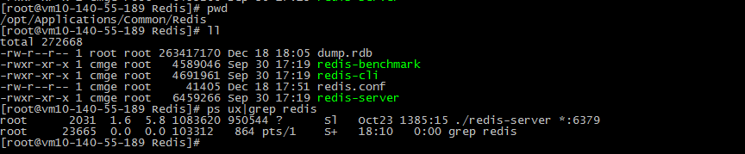

S2.2 set up Reids-py
Files:
redis-py-master.zip
Install:
~python setup.py install

S2.3 set up Nginx
Files:
nginx-1.9.2.tar.gz
Install:
~./configure --prefix=/opt/Applications/Common/Nginx --sbin-path=/opt/Applications/Common/Nginx --conf-path=/opt/Applications/Common/Nginx/nginx.conf --pid-path=/opt/Applications/Common/Nginx/nginx.pid

~make && make install
Modify Config:
Replace /opt/Applications/Nginx/nginx.conf using nginx.conf in sourcefile

Run:
~/opt/Applications/Common/Nginx/nginx -c /opt/Applications/Common/Nginx/nginx.conf
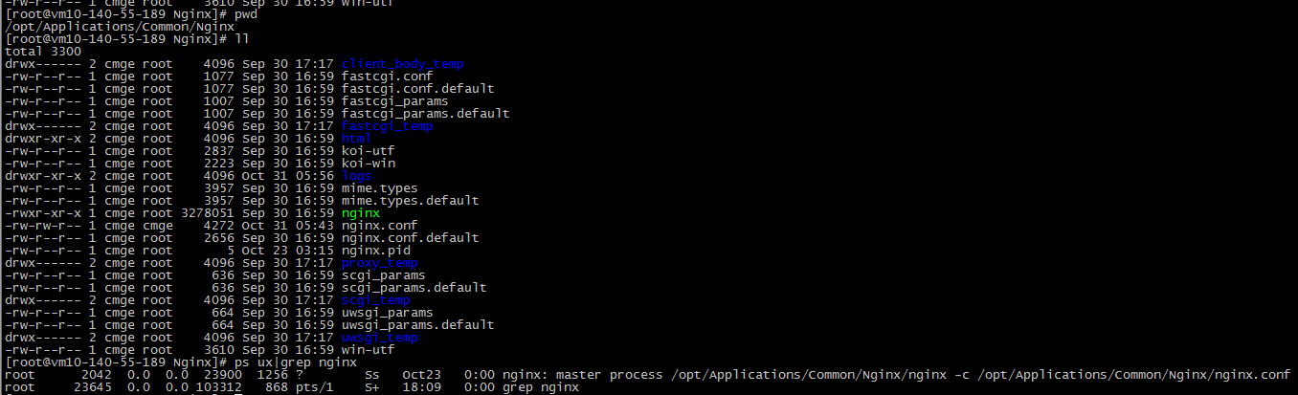

S2.4 set up WebSite
File:
Website.zip
Install:
Decompress the Website.zip to /opt/Applications/Common/WebSite/
Run:
~cd /opt/Applications/Common/WebSite/
~./startup.sh

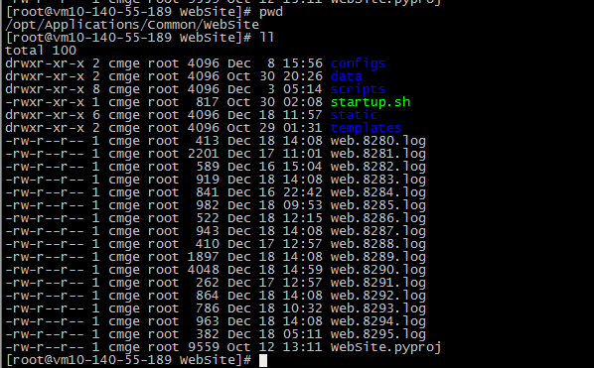

S2.5 set up GameSite
File:
GameSite.zip
Install:
Decompress the GameSite.zip to /opt/Applications/Common/GameSite/
Run:
~cd /opt/Applications/Common/GameSite/
~./startup.sh

S2.6 set up PayServer & GMServer
File:
centerServer.zip
Install:
Decompress zip file to /home/cmge/shaolin/
Run:
~nohup ./PayServerd > nohup.out_ps 2>&1 &
~nohup ./GMServerd > nohup.out_gm 2>&1 &

3 set up Game Logic Server
Software requirements
System: CentOS 6.4-6.7 64bit

S1. Set up library
yum -y install debuginfo boost-python boost-regex boost-system boost-thread glibc libgcc libicu libstdc++ libuuid ncurses-libs python python-libs readline gdb* gdb
yum -y install zip unzip tar gcc

S2. Set up dir && open port
~mkdir -p /home/cmge/shaolin/

Ensure the following ports are opened
8899, 18899

S2.1 set up logic server
File:
logicServer.zip
Install:
Decompress zip file to /home/cmge/shaolin/
Run:

~nohup ./PayServerd > nohup.out_ps 2>&1 &
~nohup ./GMServerd > nohup.out_gm 2>&1 &

4 ServerList
File:
serverlist.txt
Just put serverlist.txt into /opt/Applications/Common/WebSite/static/

